***Azure Fundamentals part 1: Describe core Azure concepts***

Benefits of Cloud:

**Scalability:**

App should handle all traffic all the time.

Horizontal Scaling:

Scale out/in

Vertical Scaling:

Scale up/down

**Elasticity:**

Enabling Auto scaler based on the traffic/cpu usage. Servers will go down after traffic cool off

**High Availability:**

99.99% (4 mins down time per month)

Though one Region goes down because any natural calamity (Strom). App should serve the customers from another region

**Agility:**

Right to customer/market. Ability to grow/move app in fast facing manner

**Disaster Recovery:**

Maintain Active-active/active-passive setting for the App. Maintaining Redundancy of you app in

Other regions in region failure situations.

**Fault Tolerance:**

**identify the differences between Capital Expenditure (CapEx) and Operational Expenditure (OpEx)**

**CapEx:**

Investing money on computers/devices waiting for returns after few years(if App successful in the market)

You will have all the machines(servers) upfront.

**OpEx:**

Pay as you go Model

You leverage cloud service on the fly based on the application needs.

Spent money monthly basis you do not use server you do not have to pay for the server.

**Different Types/ Categories of cloud Services:**

**Infrastructure-as-a-Service (IaaS):**

Virtual machines /V-net

You will have full control on O.S

**Platform-as-a-Service (PaaS):**

You upload your application and you select your app run-time.

Select the Tier (premium, standard) based on run-time created

You do not have control on hardware/VM

**Software-as-a-Service (SaaS):**

Office 365, Active directory, Drop box

Application maintained by service provider and they hold the source code for app. Provides feature.

**Share Responsibility Model:**

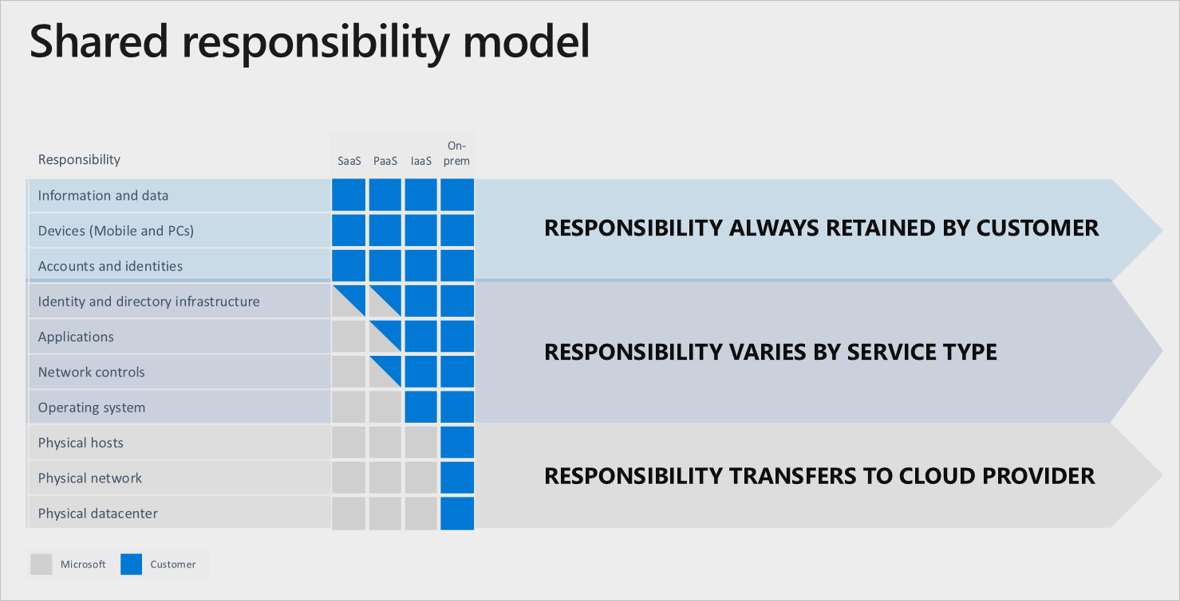

**Serverless Computing/ Serverless Model:**

There will be servers. Does required to know how many container/VM’s running under the hood.

Example: App Service, Functions

With PaaS also Scaling is your responsibility. With Serverless it is not.

Paying by hour. If no one access to you App zero $ cost.

**Azure Serverless offers**:

Azure Functions (Compute)

Azure serverless Kubernetes (compute)

Azure SQL DB serverless

Azure Cosmos DB serverless

Types of Cloud:

Public cloud

Azure, Aws, GCP

Leasing/renting services using your credit card

Hardware owned by cloud provider

Private Cloud:

You maintain own power/cooling hardware. IBM

Azure Stack

Hybrid Cloud:

Combination of private + public = Hybrid Cloud

Extending your hard drive

Multi Cloud:

More than on cloud provider

**Describe the core Azure architectural components**

**Region:**

**Geo-location**

Every region contains more than 3 AZ

**Paired- Region: (Region Pair)**

at least 300 miles away

Auto backup all apps in to paired region

Canada central – Canada West

**Availability Zone:**

Every region contains multiple Data centers

2 or more separate data center for AZ

Each zone has independent colling, power, Networking

**Subscriptions:**

Billing unit all resources available created under this sub get billing to this

One sub is equal to one Credit card

May be one Department/division/pillar

Every single resource must associate with subscription/Resource Group

One user can have admin access for one sub for another might be contributor

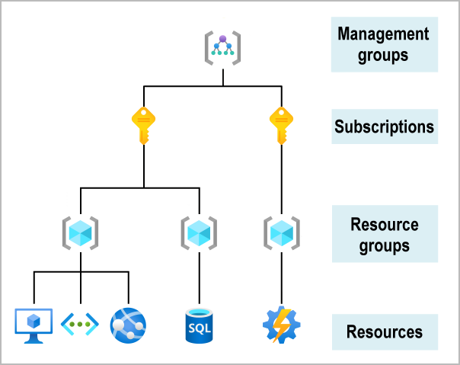

Marketing Azure sub

Finance Azure sub

HR Azure sub

Microsoft Azure Account

**Azure Resource manager (ARM):**

This is the entry point for all azure resources. If you are communicating from any tech stack for instance CLI, PowerShell, Portal, SDK. Internally it communicates with ARM.

Azure Resource:

Instance of Azure services. Any Service they referred as Resource.

***Azure Fundamentals part 2: Describe core Azure services***

**Compute:**

**VM: IaaS**

Apartment Building Example

You will get Slice server (server Rack)

Both linux & Microsoft O.S

Machine Type (cpu cores, disk size, iops)

**VM scale sets**

**Container Instance**

Deploy app as container

Push docker images in azure registry

**Kubernetes service**

**App service:( Paas)**

Service plan (Standard)

Access logs

Windows Virtual Desktop (Aws workspaces)

**Networking:**

VNet

Database

Storage

Big data

AI

IOT

Web

Mobile

Azure marketplace:

**Networking Services:**

**Services:**

VNET

VNet peering

Vpn gateway

Express Route

**Connectivity Services:**

Virtual Network:

Physical network

Virtual private network

Connect b/w two networks

Express route:

High private connection azure

**Protection services:**

DDos Protection: Distributed denial of service

Azure Protection:

Azure Firewall

Network security group

Private Link

**Delivery Services:**

Load balancer

Application Gateway

Content Delivery network

Azure front door service

**Monitoring Services**

Network Watcher

ExpressRoute Monitor

Azure Monitor

**Storage Services:**

**Azure Storage Account:**

General purpose v2(gpv2)

Container (blobs), files , tables, Queues

Azure data lake storage

Access tiers:

Hot, cold, Achieve

Performance tiers: standard or premium

Location

Redundancy/ replication

Failover options

Disk Storage:

**Database Service:**

Cosmos DB

Azure SQL DB

DB for MYSQL

DB for PostgreSQL

SQL Managed Instances

Cosmos DB:

Not only SQL

10 mil sec query

Extremely fast storage

Small piece of data not for enterprise like

Multi Model

Global Replication

Azure SQL DB:

Sql server engine managed by Azure

Replicate different region

Easy to scale or replicate

Azure Db for MYSQL:

Migrate from on-prem to Azure

Azure DB for PostgreSQL:

Migrate from on-prem to Azure

SQL Managed Instance:

SQL Server

No code changes / equivalent to SQL server

Azure marketplace:

Azure Big data analytics:

Azure Synapse Analytics (SQL Data warehouse)

Azure HDInsight

Hadoop, Hive (managed services)

Azure Databricks:

Notebooks (Real time data analysis)

Azure Data Lake

***Azure Fundamentals part 3: Describe core solutions and management tools on Azure***

**IOT Services:**

IOT Hub

IOT central

Azure Sphere

Hardware to be inserted in home appliances

**AI Services:**

Azure machine Learning

Cognitive services

Azure Bot services

**Serverless computing**

Azure Functions

Logic Apps

Event Grid

**Azure DevOps:**

Azure DevOps

GitHub

GitHub Actions

Azure DevTest Labs

**Env Management Services / tools:**

Azure Portal

CLI

Power-shell

SDK

ARM Templates

Android App

**Best Monitoring Services for Visibility, insight, and outage migration:**

**Azure Adviser:**

Recommendations service for cost, security, Performance, Reliability, operation excellence

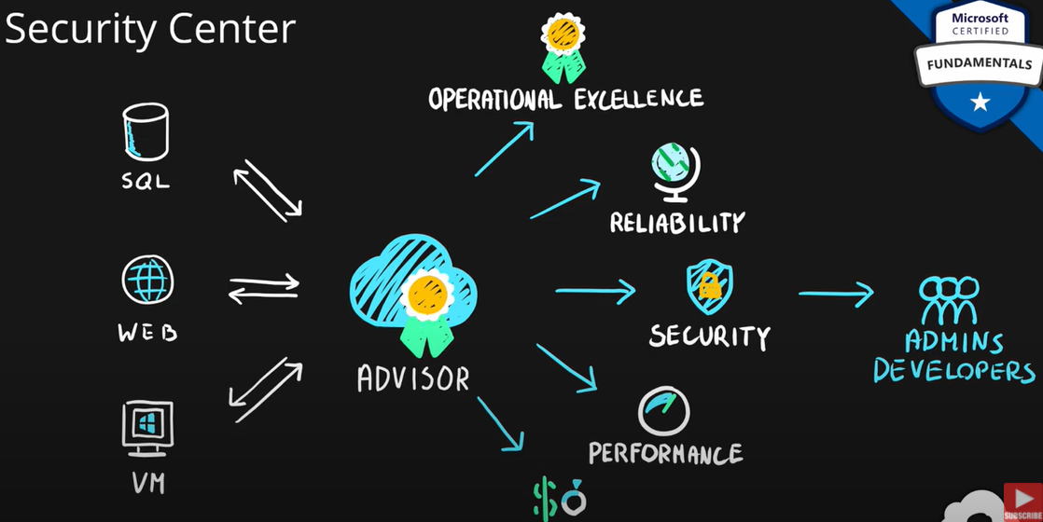

This security recommendation comes from **azure security center service**

**Azure Monitor:**

platform for collecting, analyzing, visualizing, and potentially acting based on the metric and logging data from your entire Azure and on-premises environment.

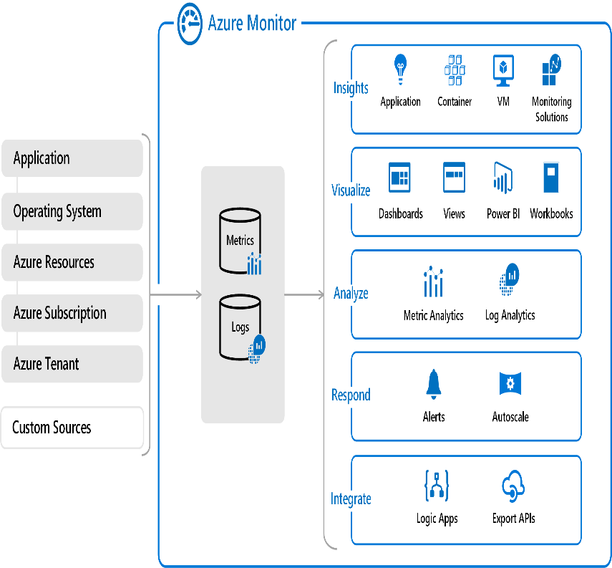

**Azure Service Health:**

**Tells you Azure service health information your services relay on**

***Azure Fundamentals part 4: Describe general security and network security features***

**Azure Security:**

**Azure Security Center:**

Scanning all your resources(services)

You can also install agent on prem servers, and you can see all of them in single dashboard

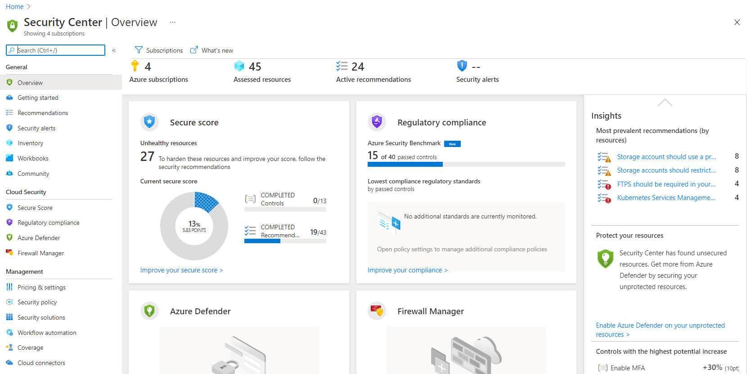

**Azure key vault:**

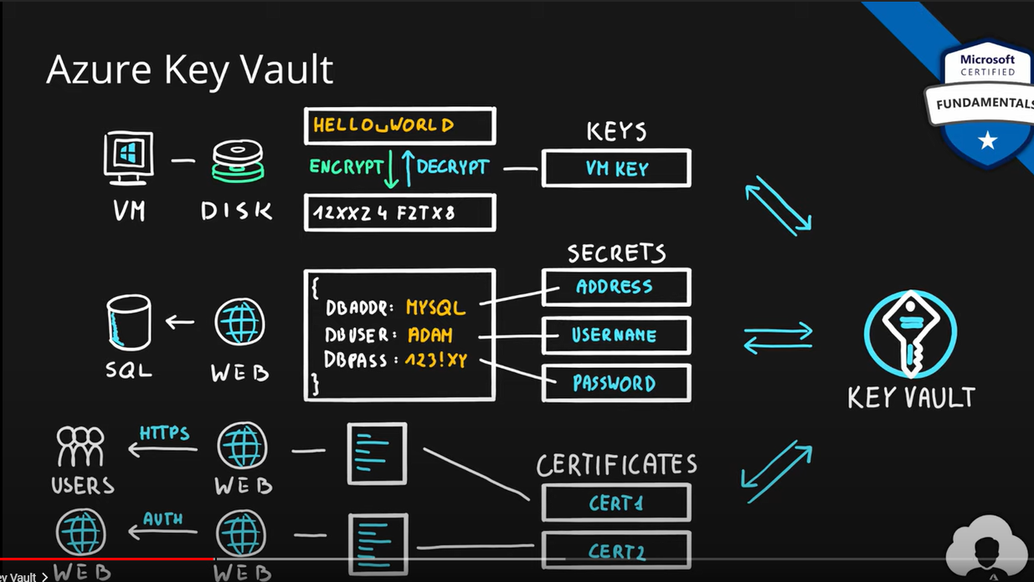

**Azure Sentinel:**

**Azure Network Security:**

**Azure firewall:**

Sateful

**DDos protection**

**Network Security Group:**

**(WAF) Web application firewall:**

**Application Gateway**

**Azure Front Door**

**Azure Content Delivery Network**

***Azure Fundamentals part 5: Describe identity, governance, privacy, and compliance features***

**Azure Active Directory (AD):**

Maintains Identity and Authorization of user

Create user add user to group

Give permission to Group like which resource group have permission like Owner or Contributor or Reader

Multi Factor Authentication:

More than one factor for your authentication

**Azure Role-based Access Control (RBAC):**

**Role:**

What identity can do

Roles Assigned to Security principle

**Security Principal:**

User

Group

Application

Role can be assigned to scope

Management Group contains multiple sub each sub contains multiple RG

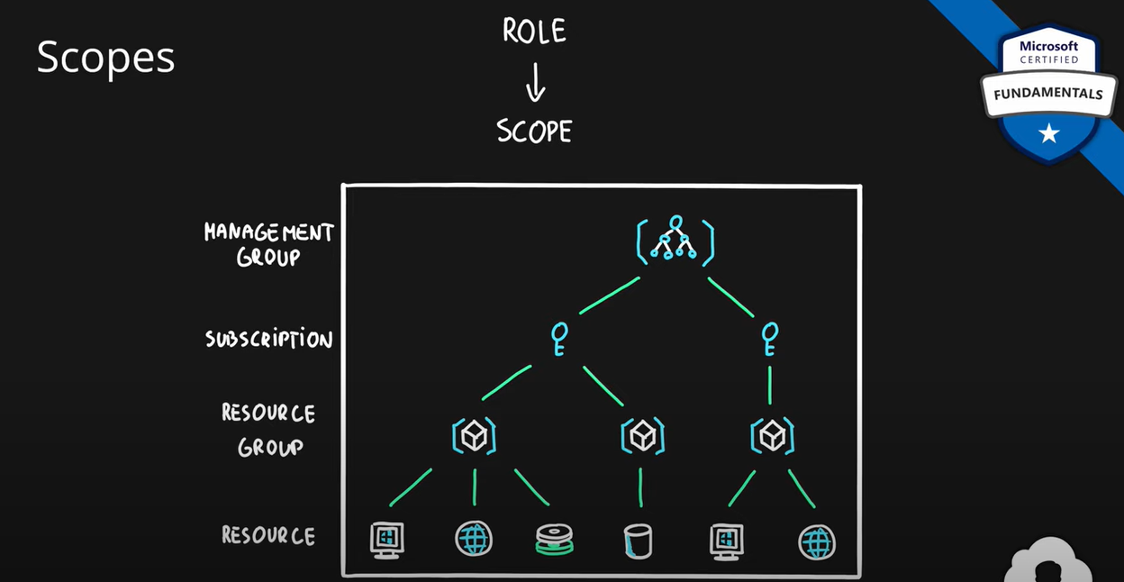

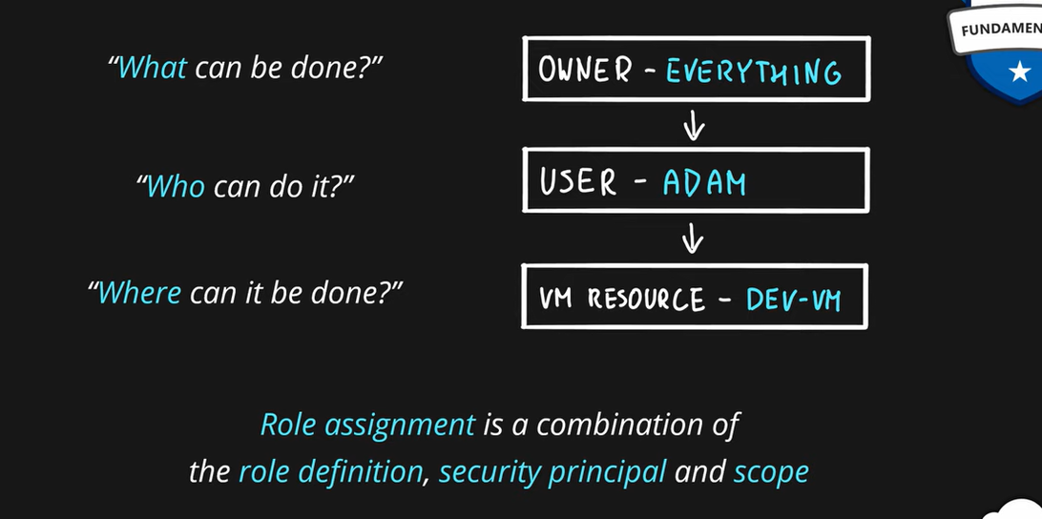

**Resource Lock:**

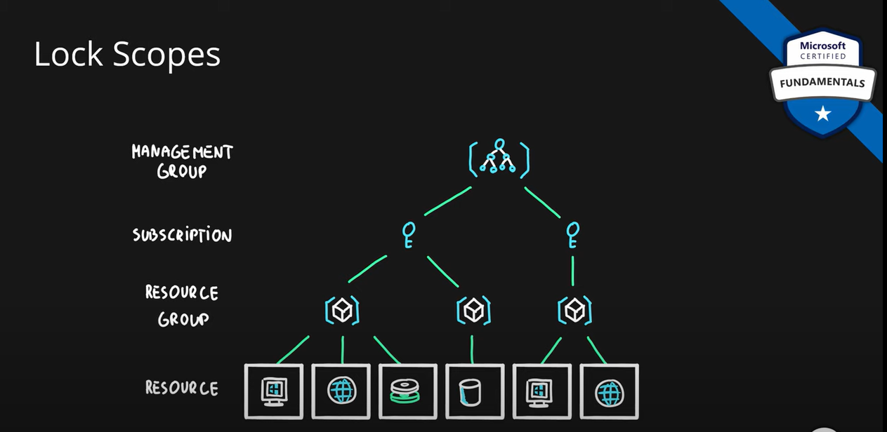

Once you add Resource lock on any Resource only deleted by Person/service who has **Owner or user access administrator Role**

**Contributor Role** not be able to delete it

Scope types:

Read: Only Read

Delete:Apart from Delete he can do any thing (if identity does not Owner/Admin Roles)

**Azure Resource Tags:**

**Azure Fundamentals part 6: Describe Azure cost management and service level agreements**

**Cost Affecting Factors**

**Resource Types:**

VM’s:

CPU

Memory

Uptime

SQL

CPU

Memory

Uptime

Storage

Functions:

Executions

Memory/sec  
Storage:

Tier

Operations

Logic Apps:

Actions

Locations:

Service pricing might different from one region to another region

**Cost Reduction Methods:**

**Reservations (Reserve Instance & Reserved Capacity):**

**Reserve Instances:**

**VM**

**Reserve Capacity:**

**SQL**

**Storage**

**Spot VM:**

you can take azure unused compute from data centers, but it can be back at point of time by azure.

Good for dev/test env, batch processing, non-critical applications

**Hybrid Benefit:**

Using existing windows os license to Azure cloud VM

They are many:

Red hat, suse , SQL server , window server

You can existing license while creating in cloud by using Hybrid benefit

Cost Reduction Methods:

Tools:

Azure pricing Calculator

TCO (total cost of ownership) calculator

**Cost Management System:**

Scope can be moved to subscription to Resource Group

You can create Budget Alerts

**Minimizing Costs:**

1. Azure pricing calculator:
2. Hybrid benefit
3. Azure cost management monitoring budgets
4. Understand lifecycle and automate
5. Autoscaling
6. Azure monitor
7. Tags & polices

Service Level Agreement:

Formal agreement of service uptime/availability

Composite SLA:

SLA of service * SLA of another service

For OR condition Like 2 vm for same app:

100%-(s1 *s2)

Azure Services Lifecycle:

